

Predicting YouTube Viewer

Metrics with Machine Learning

A project report submitted to Professor Ricky Sethi, PhD

in fulfilment of the course requirements for CS 539.

Submitted By:
Will Zawada

This report represents the work of a WPI undergraduate student as evidence of completion of a course requirement. These reports may be published without editorial or peer review. For more information about project programs at WPI, please visit: https://www.wpi.edu/project-based-learning/project-based-education.

Fall 2025

Abstract
For my Machine Learning project, I aim to investigate: To what extent can video category and metadata (duration, bitrate, frame rate) predict the numerical value of views on YouTube videos using regression models measured by RMSE and R²? I used a YouTube dataset from Kaggle, cleaned the data, and conducted exploratory analysis to examine the distribution of engagement metrics. Multiple regression approaches were applied, including Linear Regression as a baseline model, then Random Forest and Gradient Boosting. Engagement variables were highly skewed and weakly correlated with the available metadata, demonstrating limited predictive performance. Gradient Boosting performed the best (R² = 0.144, RMSE = 2.358), though it explained only a small portion of engagement variance. Feature-importance analysis and engagement-ratio comparisons showed that no strong or consistent predictors emerged despite a few relatively higher ratios for Gaming. Overall, the results indicate that basic video metadata provides minimal explanatory power, suggesting that most variation in YouTube engagement is driven by factors not captured in this dataset.

Table of Contents
Abstract 1
Table of Contents 2
Table of Figures 3
1. Introduction 4
1.1 Overview and Motivation 4
1.2 Research Question 4
2. Background 5
2.1 YouTube Dataset 5
3. Methods 6
3.1 Data Cleaning Process 6
3.2 Exploratory Data Analysis (EDA) 7
3.3 Machine Learning Models 9
4. Results 10
4.1 Model Results 10
4.2 Data Analysis 12
5. Conclusions and Recommendations 14
References 14

Table of Figures
Figure 1. Missing Values Heatmap 6
Figure 2. Post-Cleaning Summary of Variables 7
Figure 3. Histogram of Engagement Metrics 8
Figure 4. Correlation Coefficient Matrix 8
Figure 5. Engagement Ratio Summary Table 10
Figure 6. Hyperparameter Tuning Results 11
Figure 7. Feature Importance Plots 11
Figure 8. Actual vs. Predicted Scatterplots 12
Figure 9. Residual Plots 12

1. Introduction

Overview and Motivation
YouTube is a social media service provided by Google that has public videos made available for entertainment purposes. Every day I stream YouTube videos, ranging from podcasts, music videos, and movie reactions. I have also noticed that occasionally a new video will go viral and have been very curious about what causes this. I discovered a YouTube dataset on Kaggle, and with YouTube videos, I aim to investigate supervised learning models to predict engagement on YouTube videos based on metadata features such as video category. Although engagement includes views, likes, and comments, the predictive models in this project focus specifically on predicting view counts, while model performance will be evaluated through RMSE and R² metrics.
With this dataset, I aim to predict video popularity and virality based around certain categories to inform daily users, content creators, and social media analysts from Google, its parent company, for example. Prior studies have shown that features such as video category, length, and upload timing can significantly impact engagement (Dang & Zhang, 2019; Kim et al., 2020; Kaggle YouTube Data Tutorial, 2022). Implementing regression models can further enhance predictions and potentially inform recommendation systems.

1.2 Research Question
For this investigation, I will explore: To what extent can video category and metadata (duration, publish time) predict the numerical value of views on YouTube videos using regression models measured by RMSE and R²? This is a regression machine learning question. The video attributes and metadata — specifically video ID, title, URL, duration (seconds), resolution (height and width), bitrate, frame rate, codec information, video category, and hashtags serve as predictor variables, while the number of views serves as the response variable.

2. Background

2.1 YouTube Dataset
This YouTube Kaggle dataset contains 17,950 YouTube videos randomly sampled through the YouTube Data API (Kaggle YouTube Data Tutorial, 2022). It includes publicly available metadata within a wide variety of categories, with no copyrighted content. The features of the dataset include:
- Identifiers and Descriptions: Video ID, Title, URL
- Video Attributes: Duration (seconds), Resolution (height and width), Bitrate, Frame Rate, Codec Information
- Categorical Metadata: Video Category, Hashtags
- Engagement Metrics: Views, Likes, Comments
These videos span multiple genres including: Music, Entertainment, Gaming, Pets/Animals, and Technology reviews, ranging from small creators with a few thousand views to major viral hits. 17,950 rows of this data are available for data analysis. I used this full dataset initially for EDA, and then a filtered-clean version (around 15,000-17,000) for training regression models.

3. Methods

3.1 Data Cleaning Process
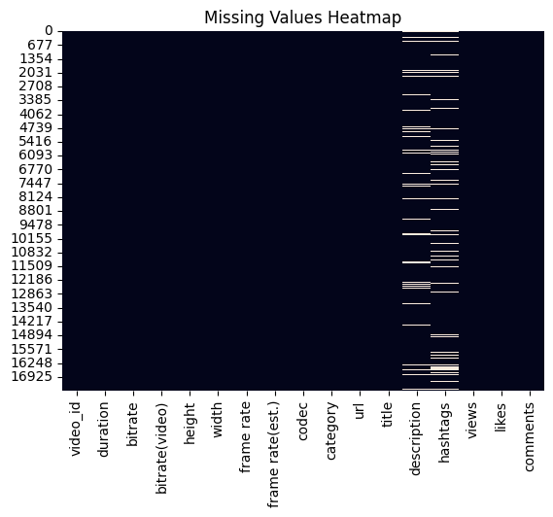
The initial inspection of this dataset showed that the column names were consistent and labeled, with no nested lists or dictionaries embedded from within the features. Duplicate rows were checked, and none were found. Afterward, the data types were inventoried. Continuous numerical features included: views, likes, comment count, duration (seconds), height, width, bitrate, and frame rate. While categorical and nominal features included: video category, codec, and hashtags with the text fields, video title and URL being retained for future analysis. Timestamps were correctly stored as object strings and can be converted to datetime for future exploration. A missing-value assessment revealed that there were relatively small proportions of null entries across most columns (Figure 1).
Figure 1. Missing Values Heatmap

Then, the numerical columns were filled with their respective means, and categorical columns were filled with their modes. Once these steps were implemented, the dataset contained no remaining “nulls”. No major formatting errors or out-of-range values were found, and all of the variable types have matched their feature descriptions (Figure 2).
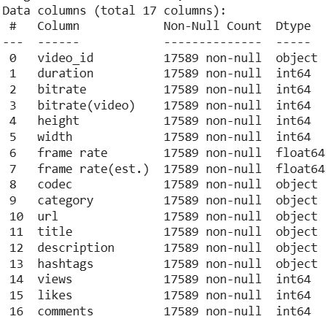
Figure 2. Post-Cleaning Summary of Variables

3.2 Exploratory Data Analysis (EDA)
After cleaning the YouTube dataset, I performed exploratory statistical analysis to understand the distribution and relationships among the key variables. I chose to include a small subset of this in the report, though my full EDA can be viewed within the Process Notebook.
We can see that engagement metrics (views, likes, and comments) were highly right-skewed (Figure 3), with most videos receiving low interaction:
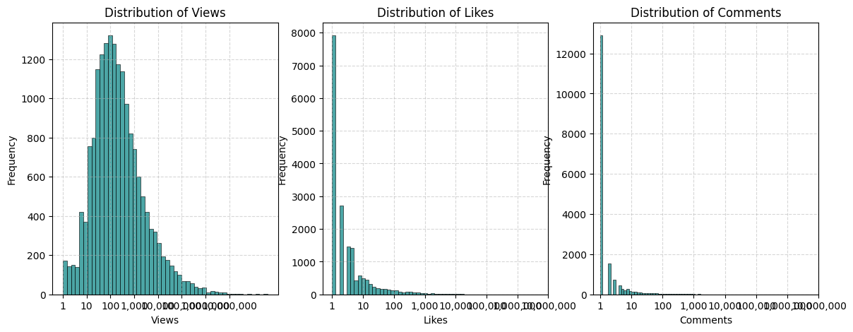
Figure 3. Histogram of Engagement Metrics

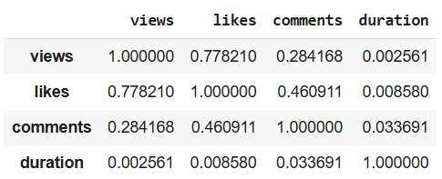
I then computed correlation coefficients with views and likes within a correlation matrix (Figure 4):

Figure 4. Correlation Coefficient Matrix

This matrix showed a strong positive correlation, meaning more viewed videos tend to receive more likes. Meanwhile, comments correlated moderately with both views and likes, suggesting audience interaction scales with visibility, but not as strongly as likes. Duration had a weak or inconsistent relationship with engagement, implying that longer videos do not necessarily yield higher interactions.

3.3 Machine Learning Models
These Machine Learning models were implemented using scikit-learn 1.x in Python 3.11. After doing some initial EDA, I narrowed down the scope of my project to focus on using Random Forest and Gradient Boosting models to compare the R² and RMSE measurements of video duration, bitrate, and frame rate (independent X variables) against views per video (the dependent variable). The intent of using both of these regression models is to compare their R² and RMSE measures of accuracy to draw conclusions about how metadata influences viewer engagement.
Then, to contextualize the performance of the Random Forest and Gradient Boosting models, I added a simple Linear Regression baseline model only as a baseline comparison. I also expanded the predictor set to include encoded video categories to align with prior feedback. Because the primary predictive models in this project were tree-based (Random Forest and Gradient Boosting), the categorical metadata (‘video category’) was encoded using scikit-learn’s LabelEncoder. The video duration, bitrate, frame rate, and category encoded features were kept, while all of the other features were dropped.
Tree-based models handle integer-encoded categories without assuming an ordinal relationship, making LabelEncoder appropriate and computationally efficient. However, no additional encoding (e.g., one-hot encoding) was applied to the baseline model. I also would've done upload hour, however, that data was not available from within this dataset. Throughout these models, I applied a $log(y+1)$ transformation to reduce skewness (since the dataset is large and heavily right-skewed) and stabilize variance. The models were then trained after applying Min/Max scaling to the feature set, followed by splitting the X-values into training/testing data into an 80-20 split.
Additionally, I included an engagement ratio to lean into the additional insights of how the popularity of viewership is impacted by specific video categories. Lastly, I included three model performance visualizations: feature importances, an actual vs. predicted scatter plot, and a residual plot for the Random Forest and Gradient boosting models. These visualizations help to further understand model behavior and diagnose prediction patterns.

4. Results

4.1 Model Results
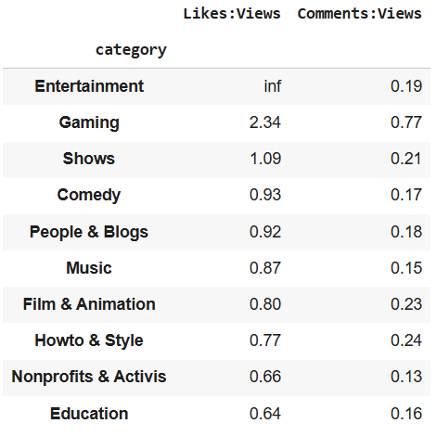
After implementing the baseline Linear Regression model, it produced an R² value of 0.017 and an RMSE of 2.528. Then, with the Random Forest model, it produced an R² value of 0.050 and an RMSE of 2.485. Lastly, with the Gradient Boosting model, it produced an R² value of 0.144 and an RMSE of 2.358. Additionally, the engagement ratio summary table shows the ratios of likes to views and comments to views (Figure 5).
Figure 5. Engagement Ratio Summary Table

Then, to ensure a fair comparison between the Random Forest and Gradient Boosting models, I performed hyperparameter tuning via GridSearchCV for each algorithm. The grids were intentionally kept small to prevent overfitting and to highlight whether model performance could be improved beyond the default settings. Each model was tuned using RMSE-based cross-validation, and the best-performing parameter sets are reported below (Figure 6):

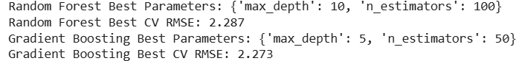
Figure 6. Hyperparameter Tuning Results

Lastly, I included three model performance visualizations: feature importances (Figure 6), an actual vs. predicted scatter plot (Figure 7), and a residual plot (Figure 8) for the ensemble Random Forest and Gradient Boosting models. Below, these each help to further understand model behavior and diagnose prediction patterns:
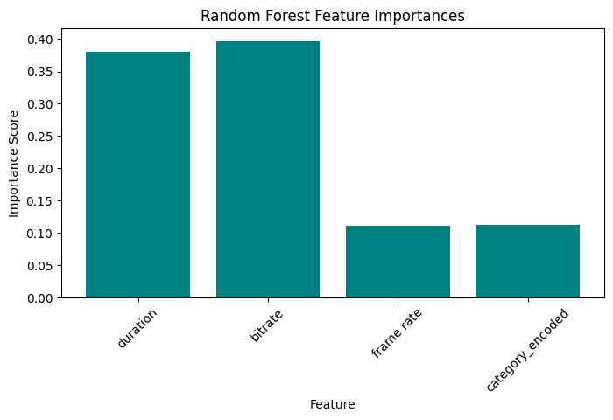
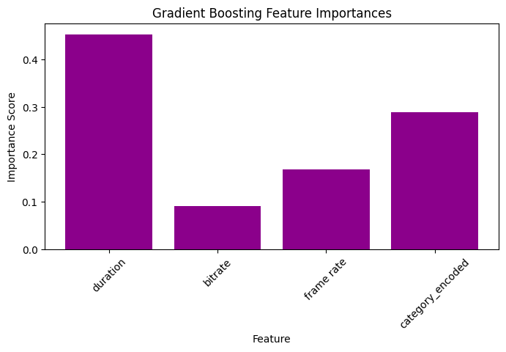
Figure 7. Feature Importance Plots
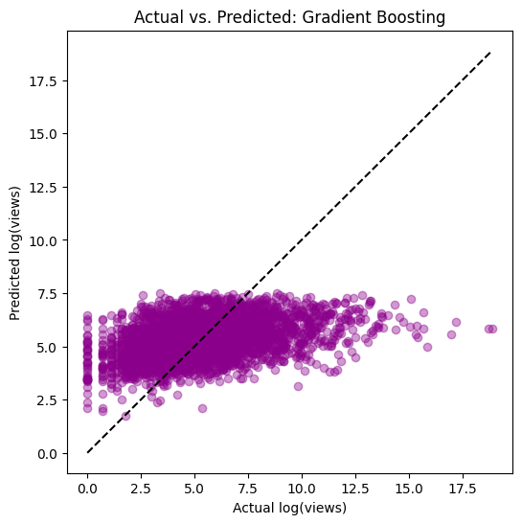
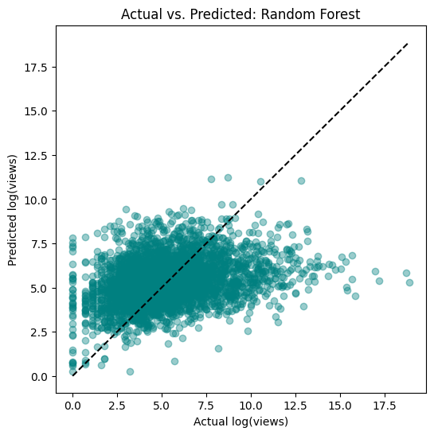
Figure 8. Actual vs. Predicted Scatterplots

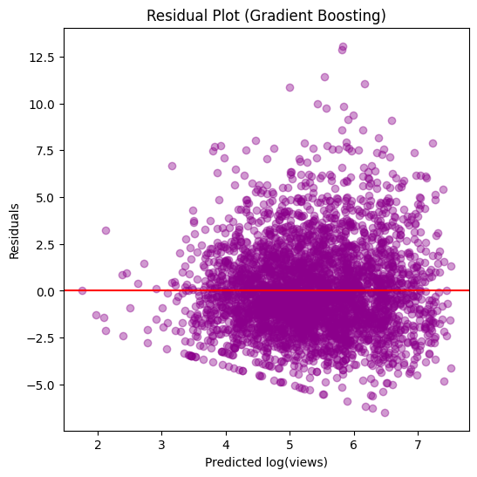
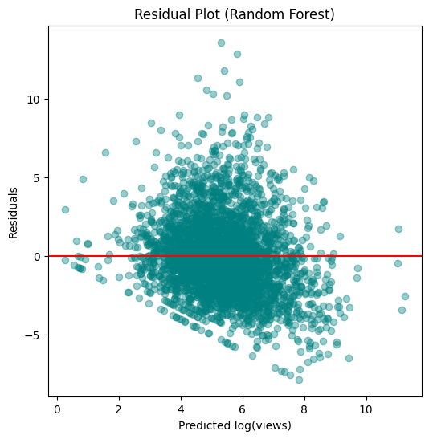
Figure 9. Residual Plots

4.2 Data Analysis
We can see initially that the engagement metrics were heavily skewed and only weakly related to basic video metadata. This aligned with the poor performance of linear regression (R² = 0.017, RMSE = 2.528) and the diagnostic plots, which showed a consistent underestimation of high-engagement videos. Tree-based models captured more nonlinear structure, but the Random Forest provided only a small improvement (R² = 0.050, RMSE = 2.485), and even Gradient Boosting—the best model, explained just 14% of engagement variance (R² = 0.144) while achieving the lowest prediction error (RMSE = 2.358).
The RMSE values here represent the average prediction error in log-transformed view counts, so lower scores indicate better accuracy. For example, we see that the log-RMSEs of 2.358 (Gradient-Boosting) implies that the predictions are off by about a factor of ${10}^{2.358}≈228$ on the original scale. Although Gradient Boosting reduced RMSE compared to the baseline, the improvement was modest, reinforcing that the metadata features alone have limited predictive power.
The feature-importance plots indicated that bitrate and duration contributed more to predictions than the other metadata features. Also, the engagement-ratio comparisons showed some category-level differences. For example, Gaming had significantly higher ratios (likes-to-views = 2.34, comments-to-views = 0.77). We also see that shows had higher likes-to-views ratios at 1.09, with comedy at 0.93, and people/blogs at 0.92.

5. Conclusions and Recommendations
These findings suggest that Gaming videos tend to drive video engagement more than most other video categories, with likes tending to receive more engagement than comments. While some categories appear more engaging than others, both category and technical metadata offer limited predictive value. Overall, these predictive models should incorporate richer behavioral and semantic features. The current findings indicate that most variation in YouTube engagement is driven by factors not present in this dataset, such as content quality, audience behavior, channel reputation, and recommendation-based algorithms. This is largely due to missing semantic and behavioral metadata such as channel subscriber count, upload timing, title text embeddings, thumbnail features, and NLP-based attributes.

References
Dang, J., & Zhang, Y. (2019). Predicting YouTube Video Popularity Using
Machine Learning Techniques. International Journal of Data Science.
Kim, J., Lee, S., & Park, H. (2020). Understanding Engagement Patterns on
YouTube: Metadata, Views, and Likes. Journal of Social Media Analytics.
Kaggle Tutorial (2022). YouTube Video Analysis: Predicting Popularity.
https://www.kaggle.com/datasets/cyberevil545/youtube-videos-data-for-ml-and-trend-analysis

